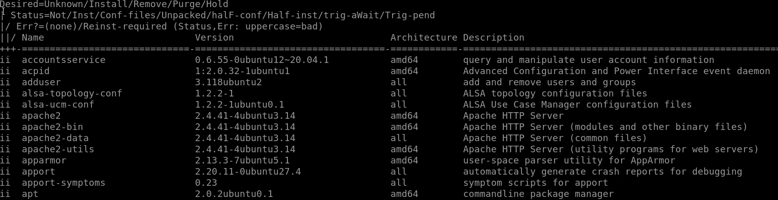Below are the details of the Ubuntu 20.04 server with Apache2 installed hosted on AWS Lightsail:

